Nursery Cycle 1
Autumn

Text | Genres of Writing | Skills Covered
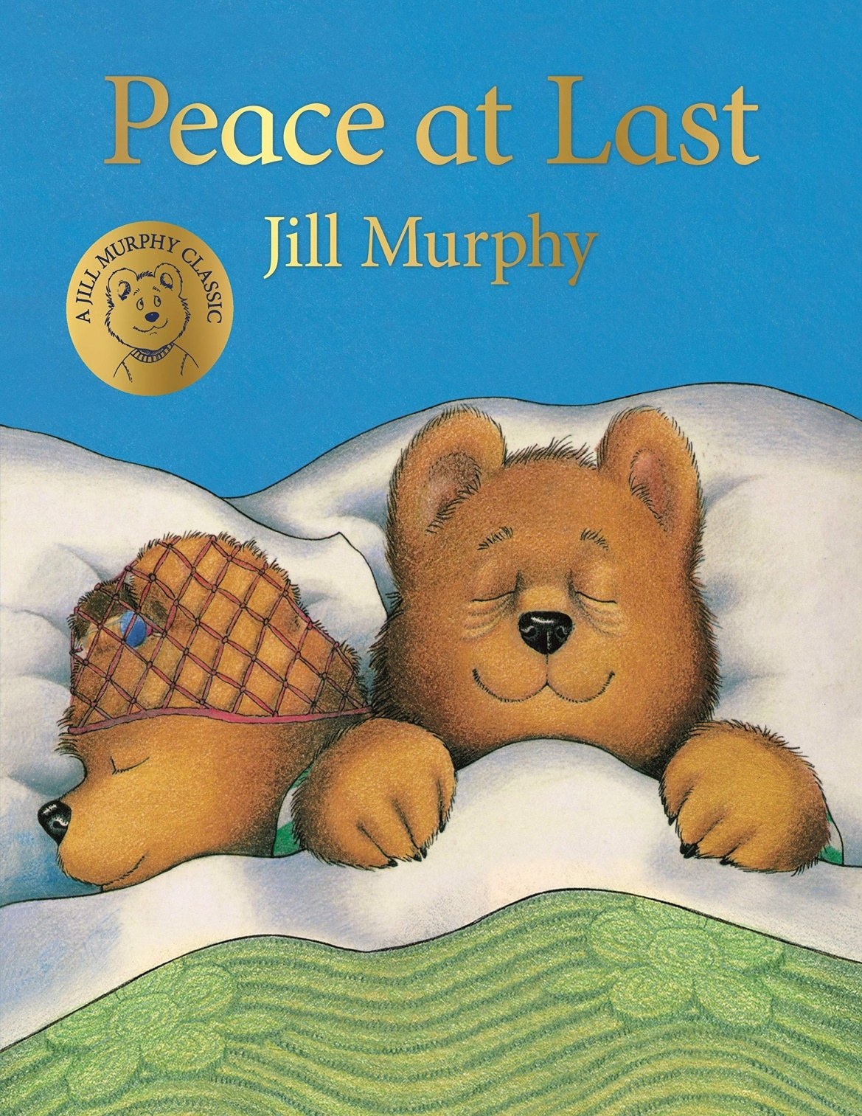  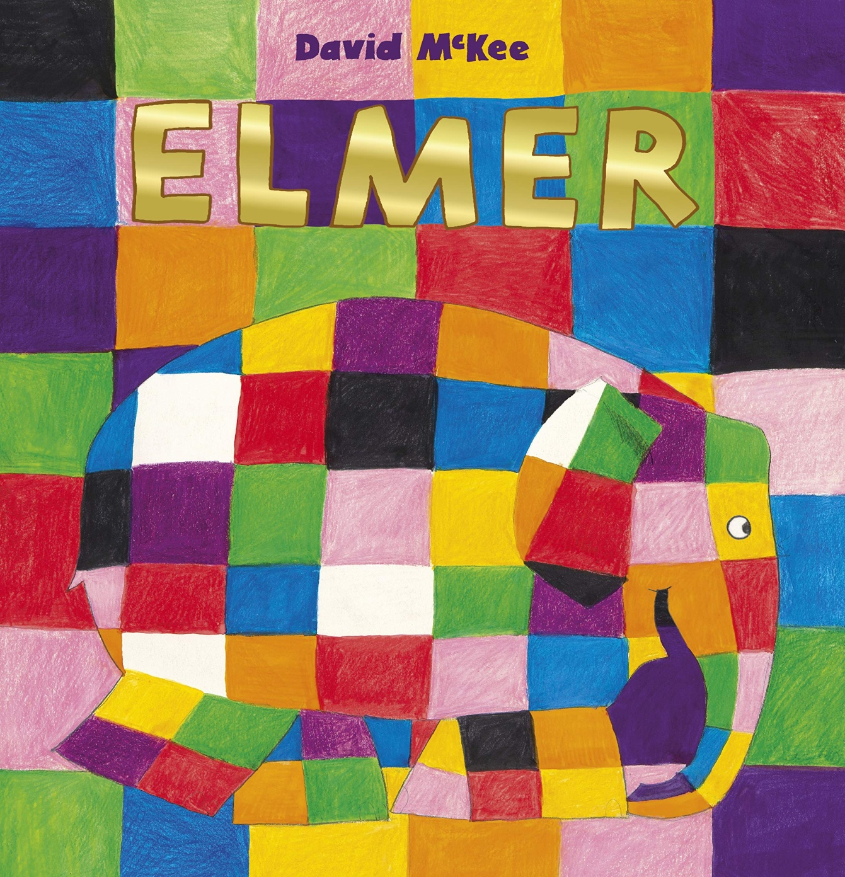  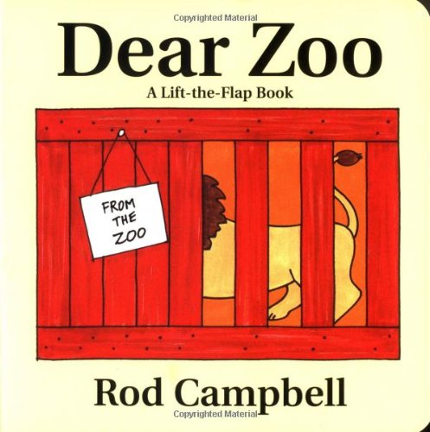  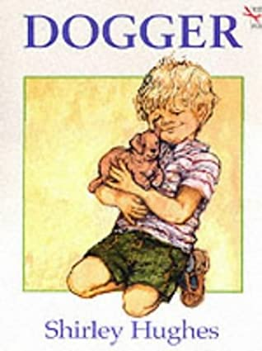 |  | Children will include mark making and early writing in their play.  Children will imitate adults writing by making continuous  Lines of shapes and symbols (early writing) from left to write.  Children give meaning to marks as they draw and paint  Children will write some or all of their name using their name card to copy
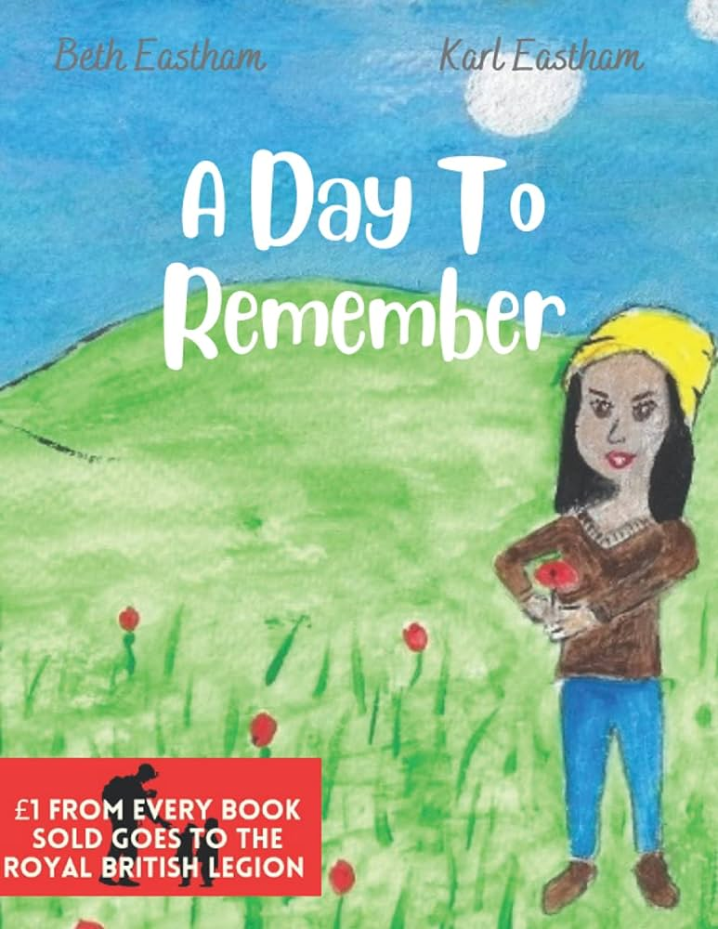  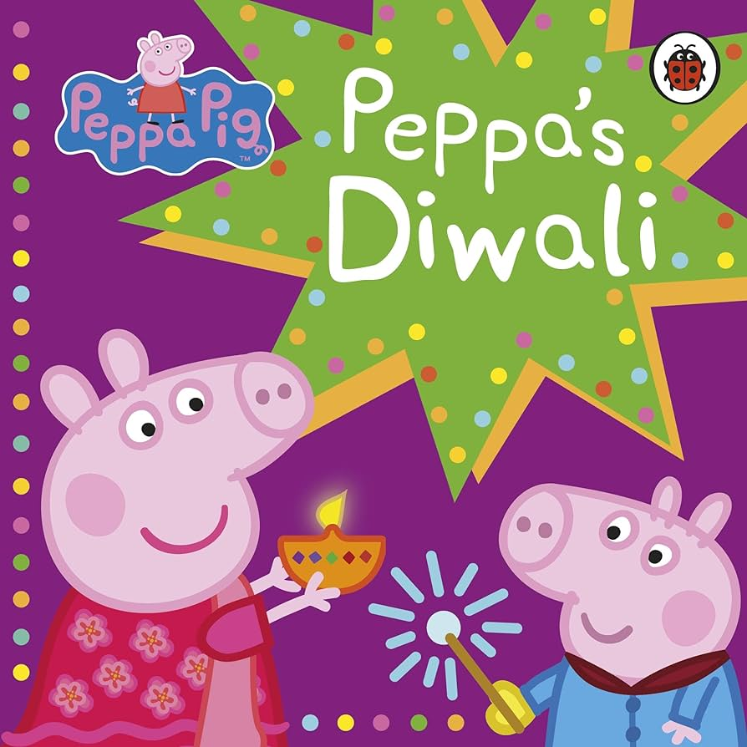  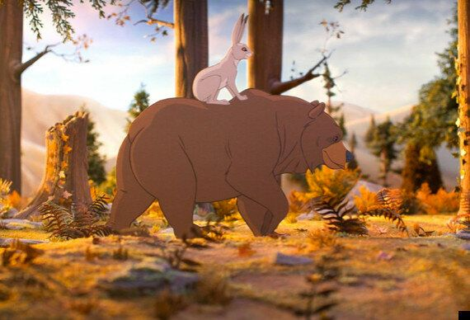  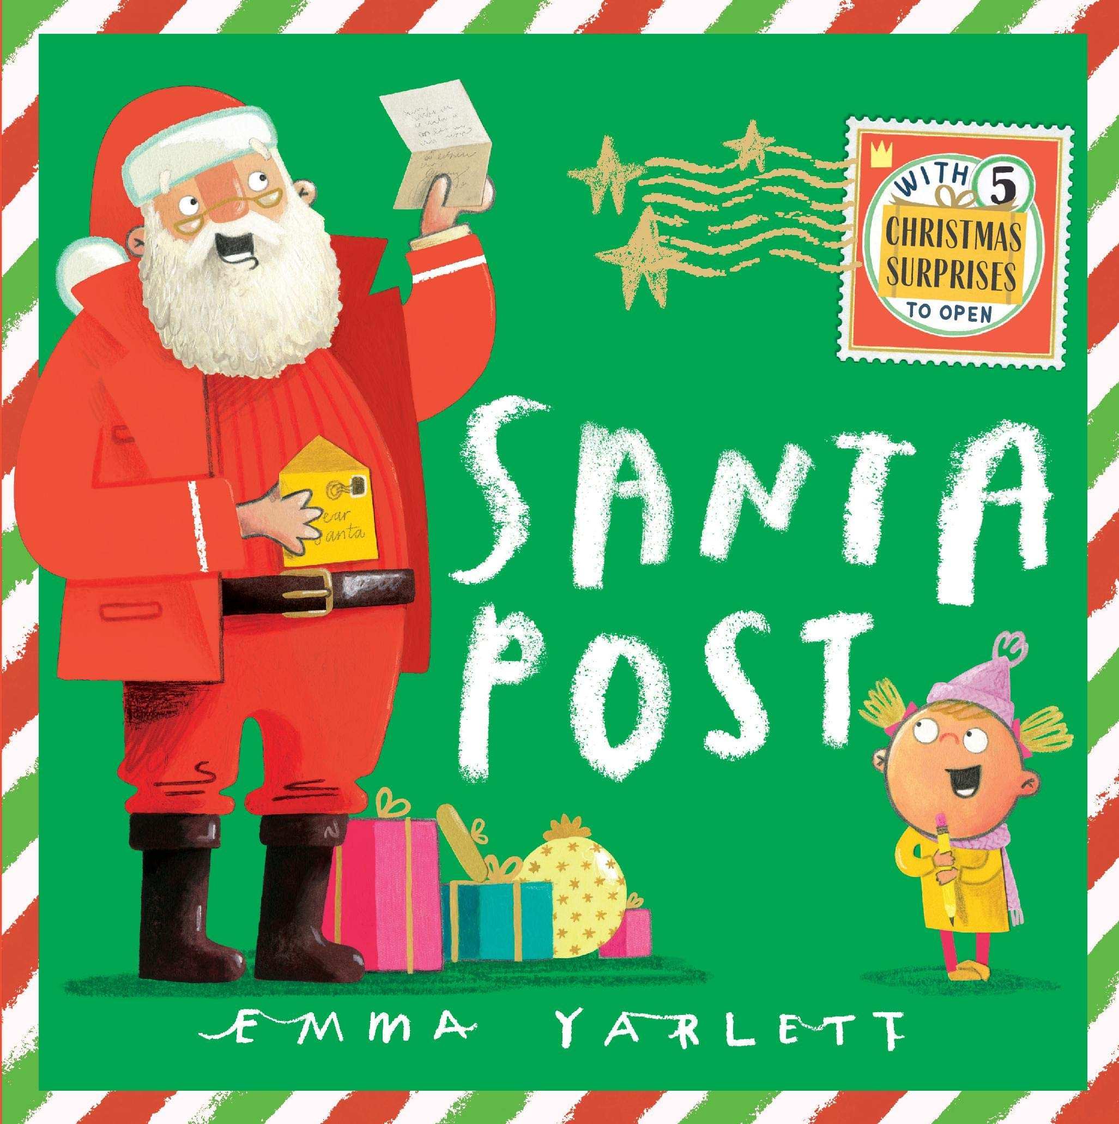  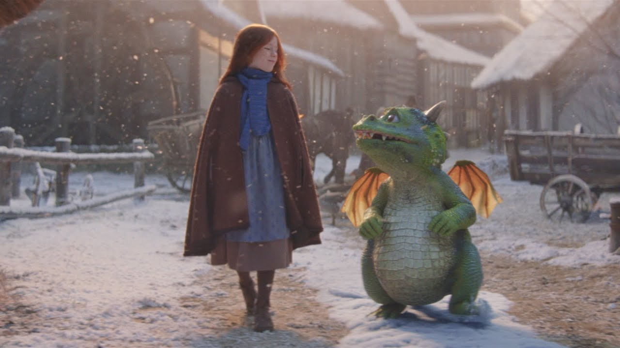 |  | Children will include mark making and early writing in their play.  Children will write some or all of their name using their name card to copy  Children will imitate adults writing by making continuous  Lines of shapes and symbols (early writing) from left to write.  Children give meaning to marks as they draw and paint

Spring

Text | Genres of Writing | Skills Covered
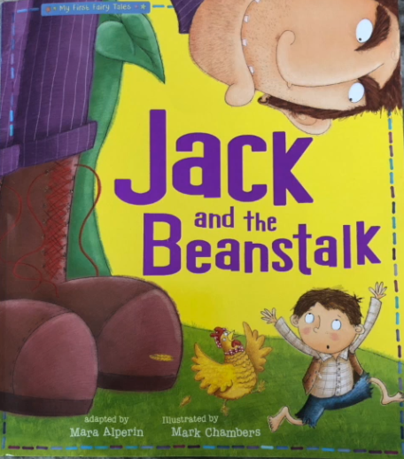  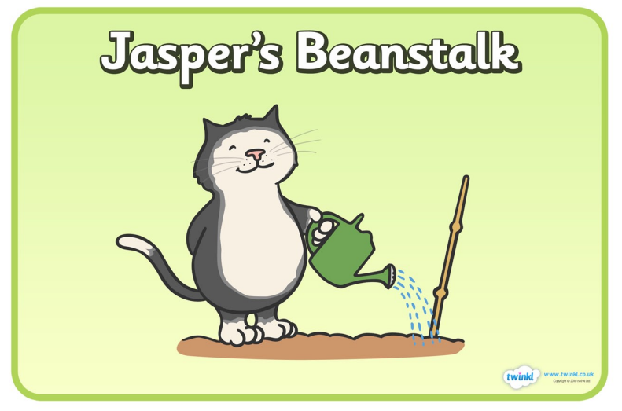  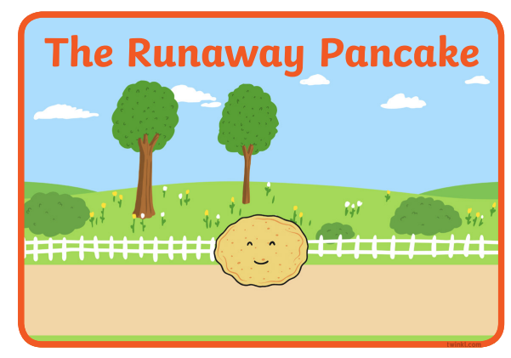  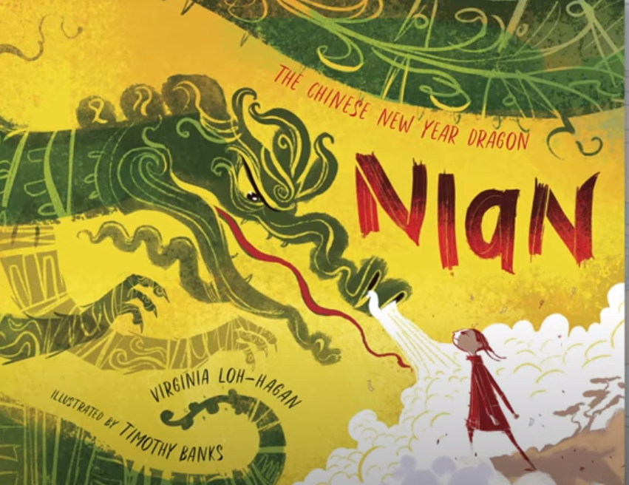  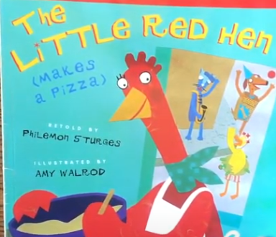  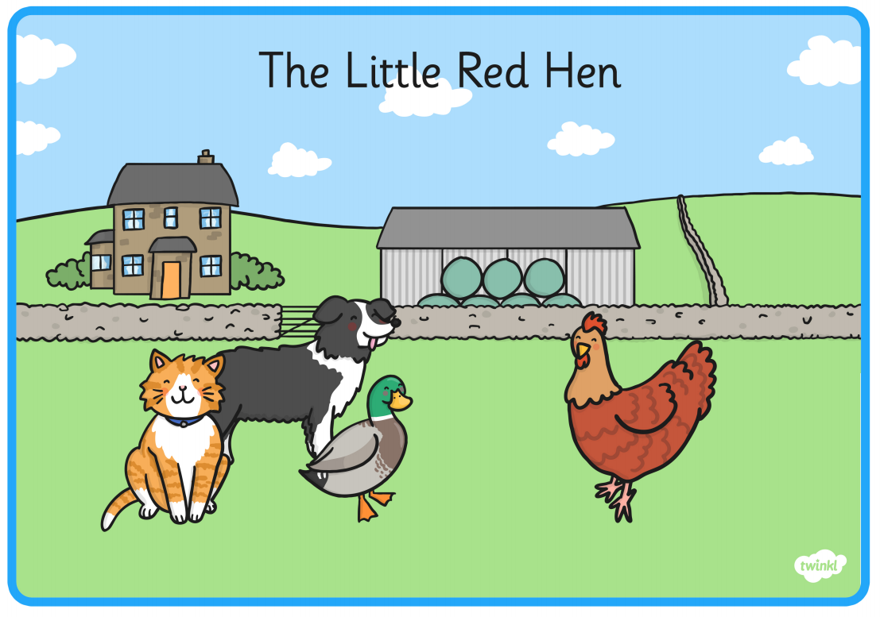 |  | Knows that the marks they make are of value.  Make marks on their picture to stand for their name.  Add some marks to their drawings, which they give meaning to. For example “ that says mummy”.  Children will write some or all of their name using their name card to copy  Uses some of their print and letter knowledge with support in early writing such as a pretend shopping list/ birthday card
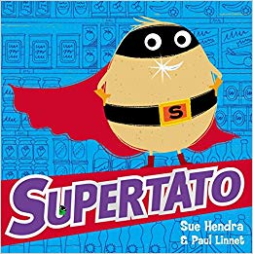  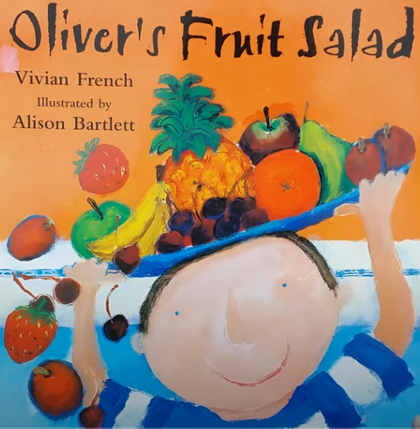  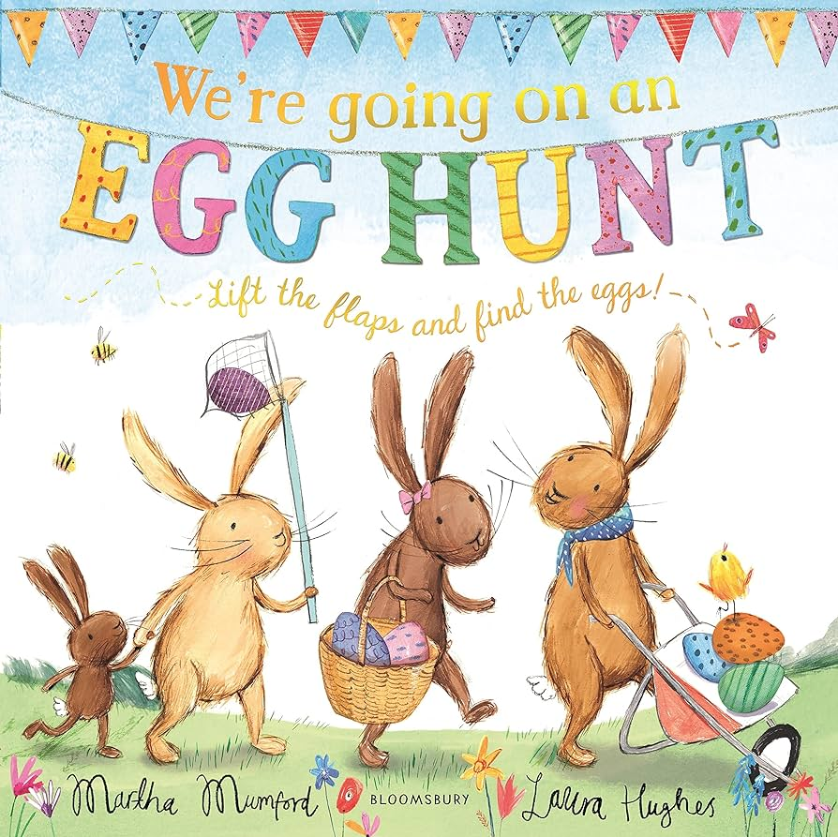 |  | Knows that the marks they make are of value.  Make marks on their picture to stand for their name.  Add some marks to their drawings, which they give meaning to. For example “ that says mummy”.  Children will write some or all of their name using their name card to copy  Uses some of their print and letter knowledge with support in early writing such as a pretend shopping list/ birthday card  Begins to write initial sounds as captions for drawings

Summer

Text | Genres of Writing | Skills Covered
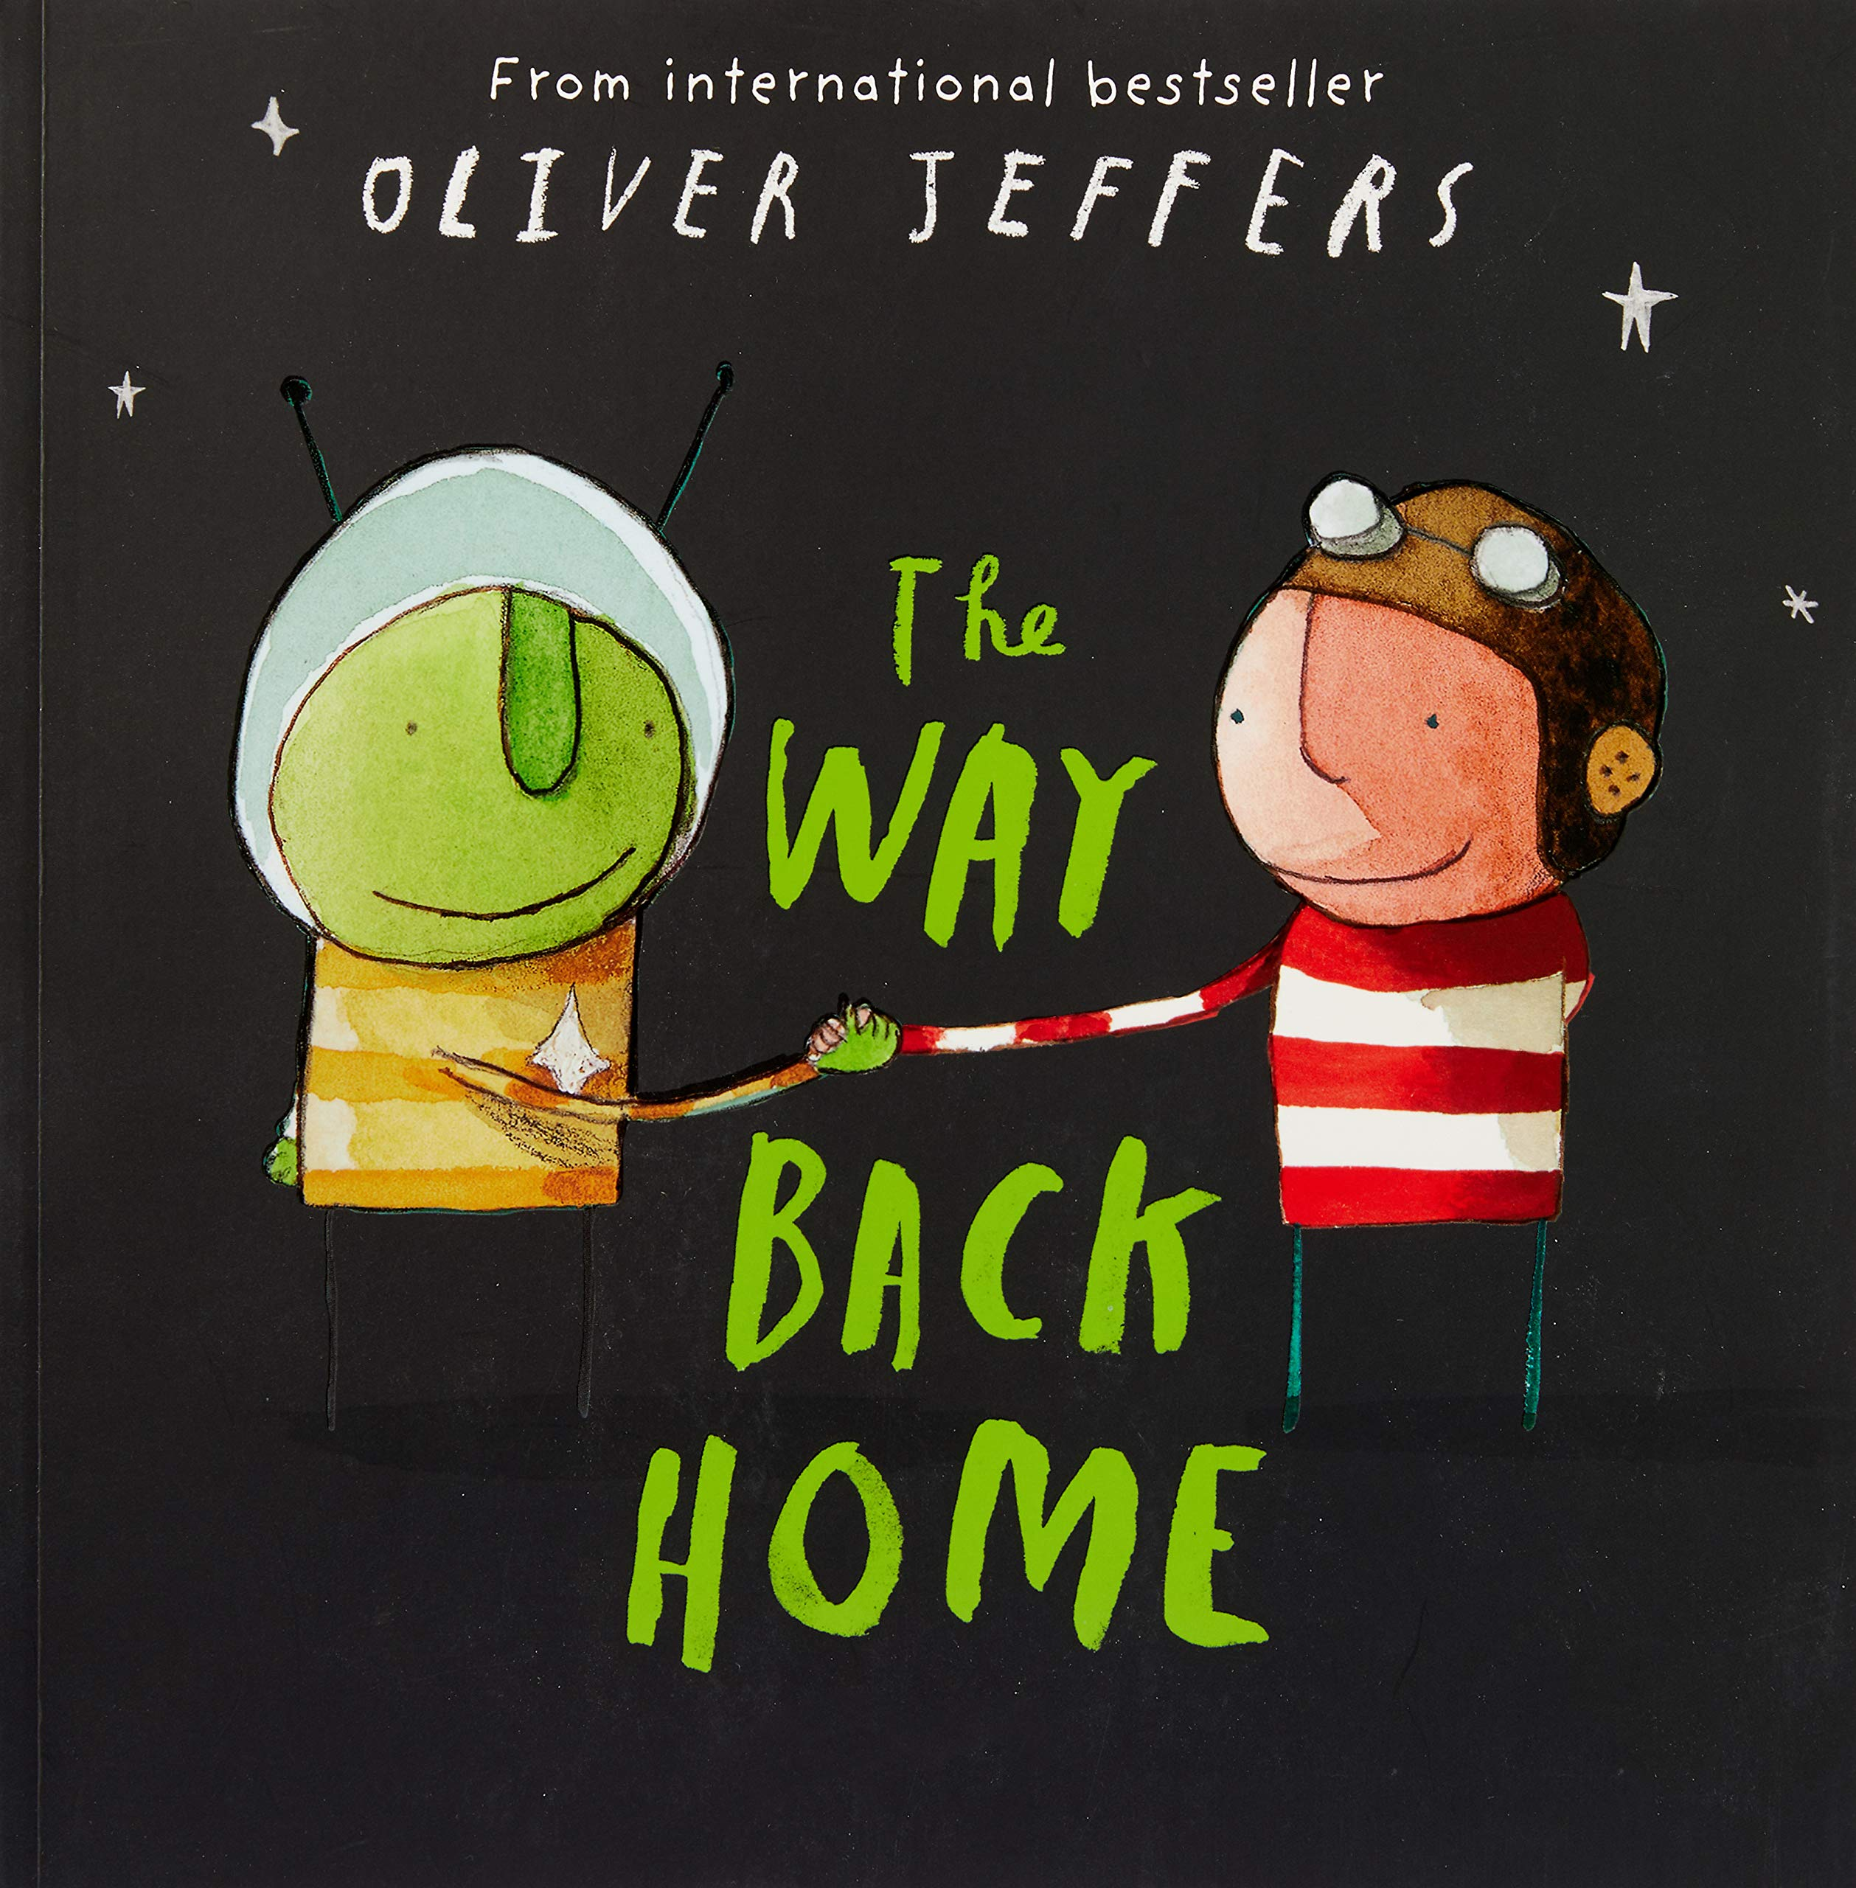  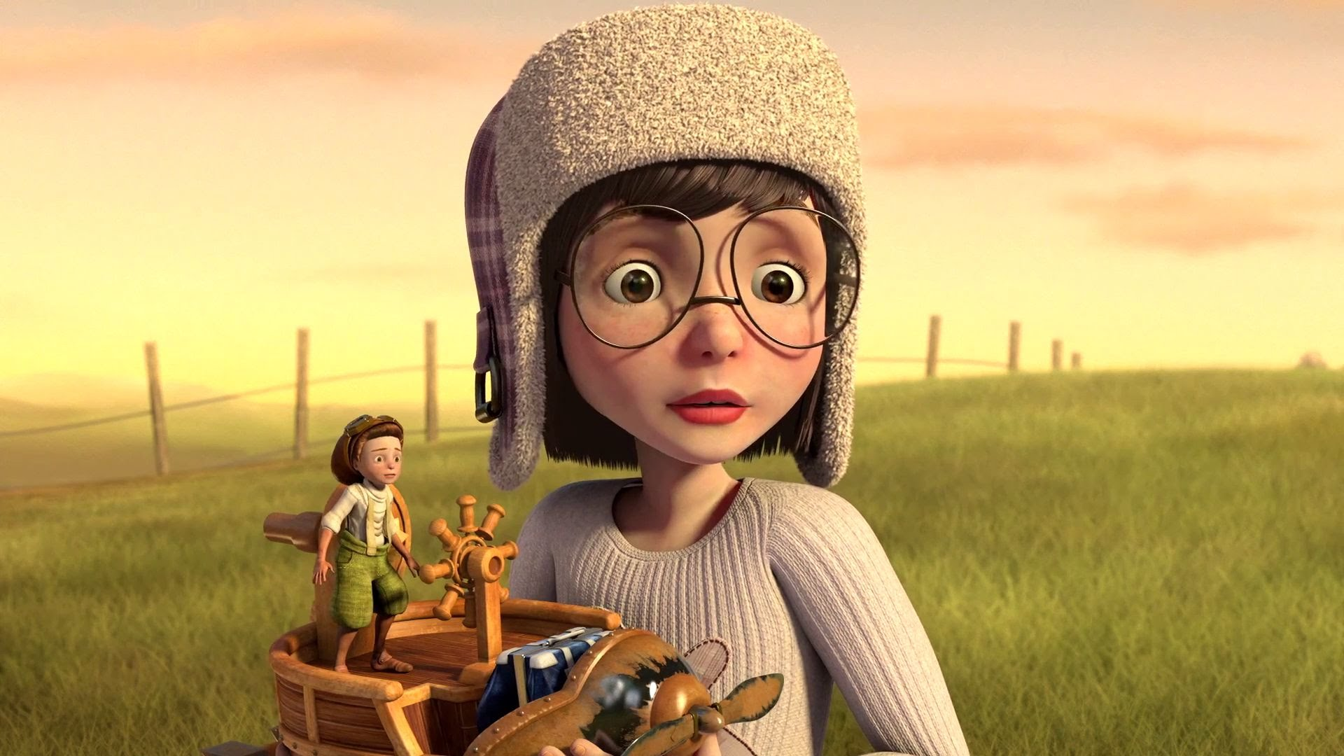  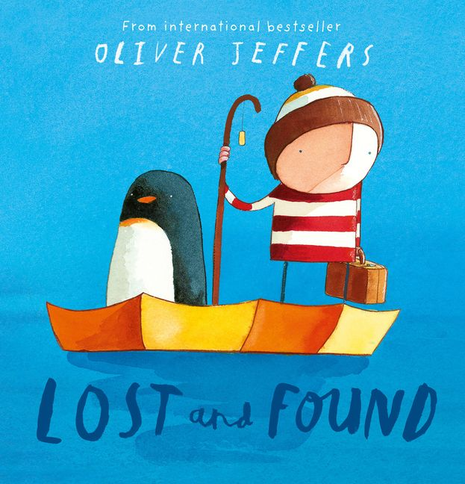  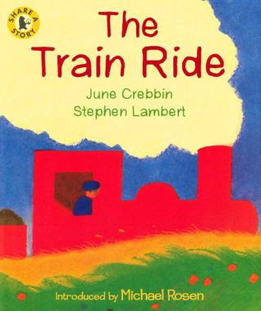  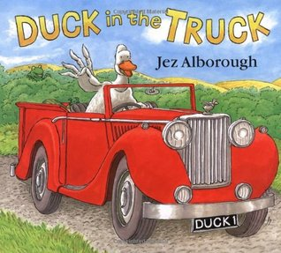  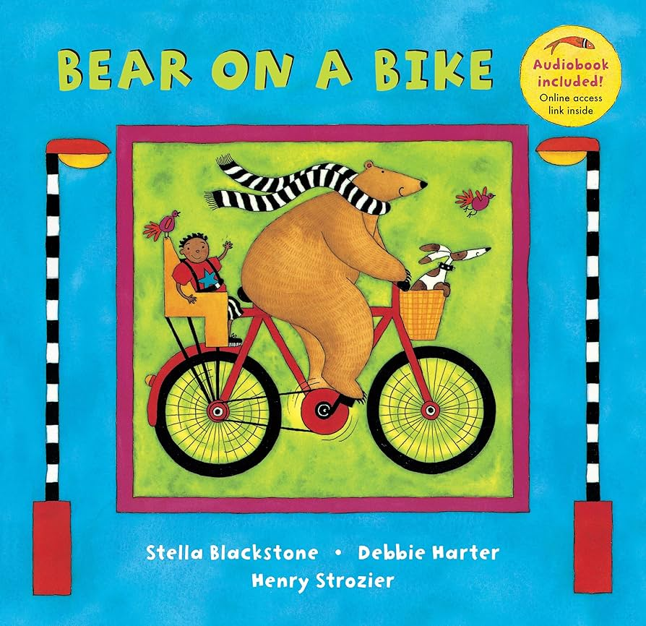  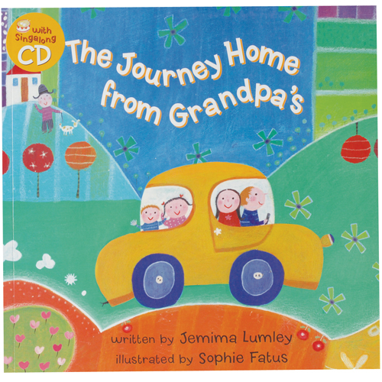 |  | Children will enjoy drawing freely.  Children will give meaning to the marks they make.  Children will make marks on the paper to stand for their name.  Children can write their first name independently  Children will sequence a story that they know well  Children can write some letters accurately.  Uses print and letter knowledge learnt independently in writing.  Some children will be able to write simple cvc words.
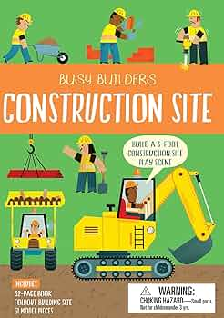  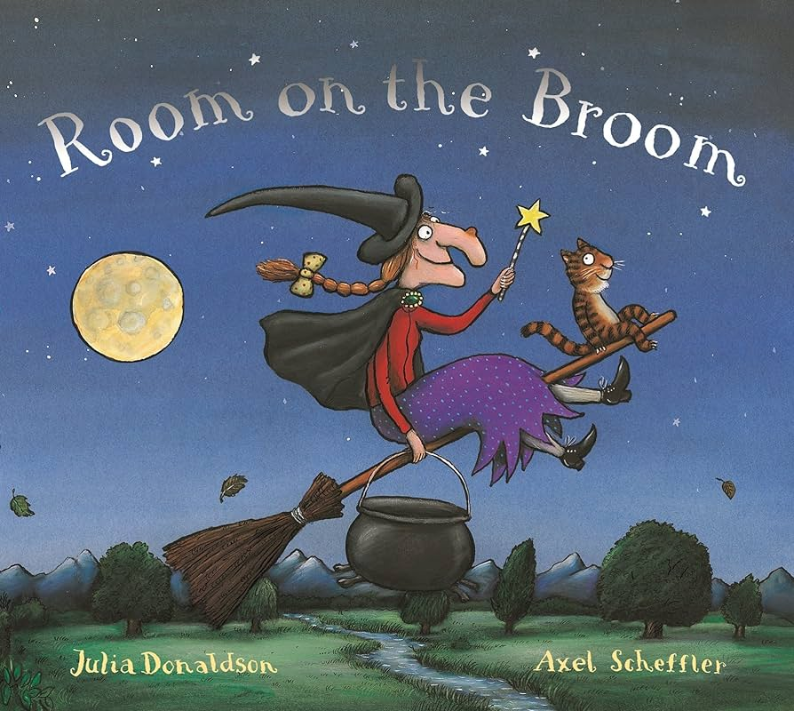  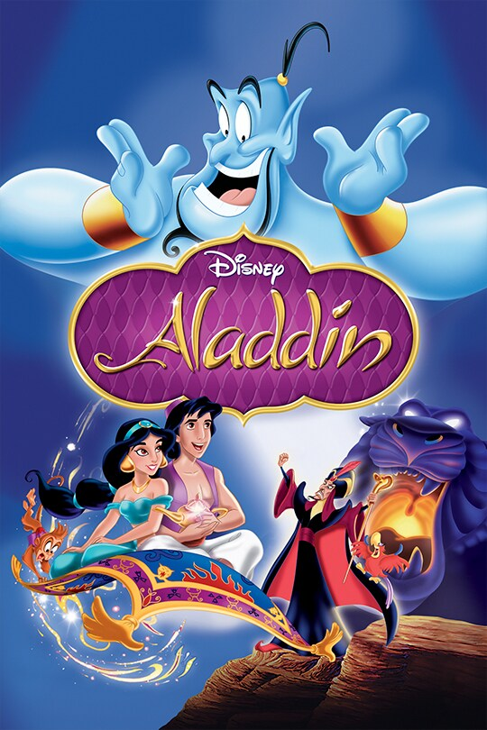  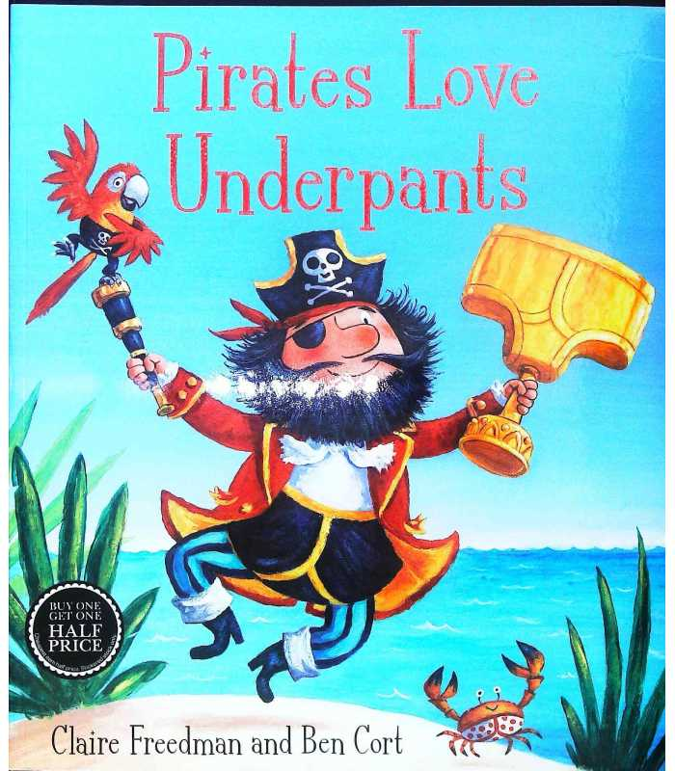  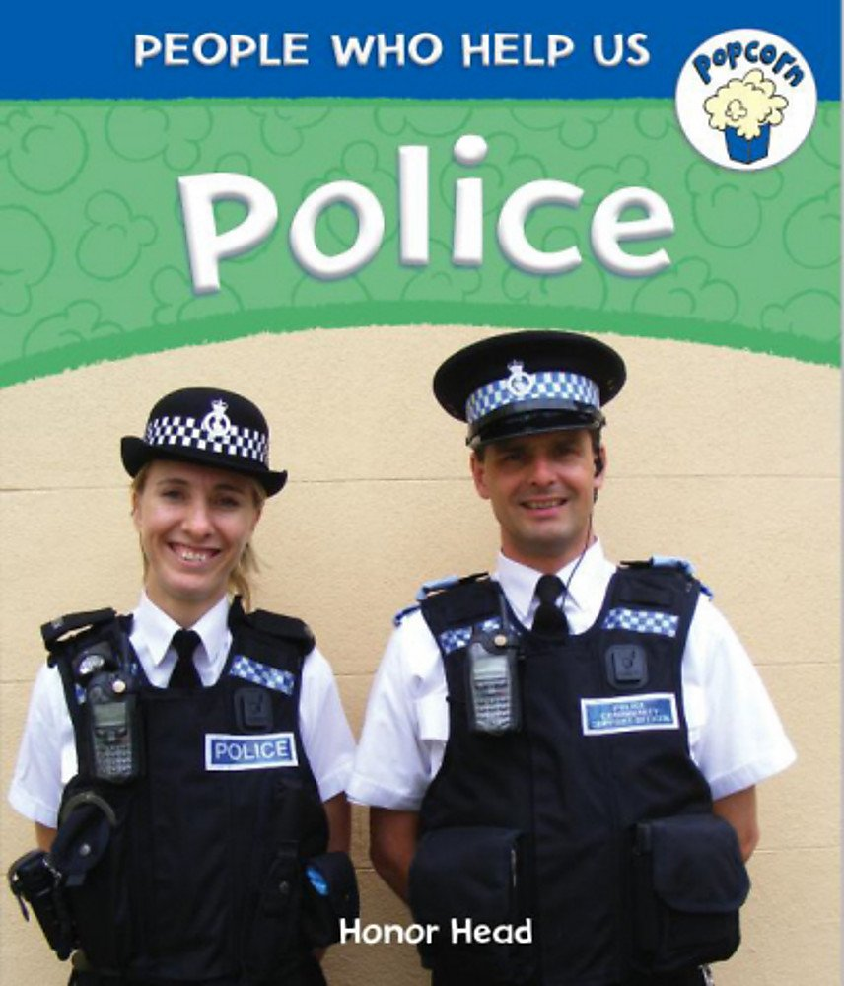 |  | Children will enjoy drawing freely.  Children will give meaning to the marks they make.  Children will make marks on the paper to stand for their name.  Children can write their first name independently  Children will sequence a story that they know well  Children can write some letters accurately.  Uses print and letter knowledge learnt independently in writing.  Some children will be able to write simple cvc words.

